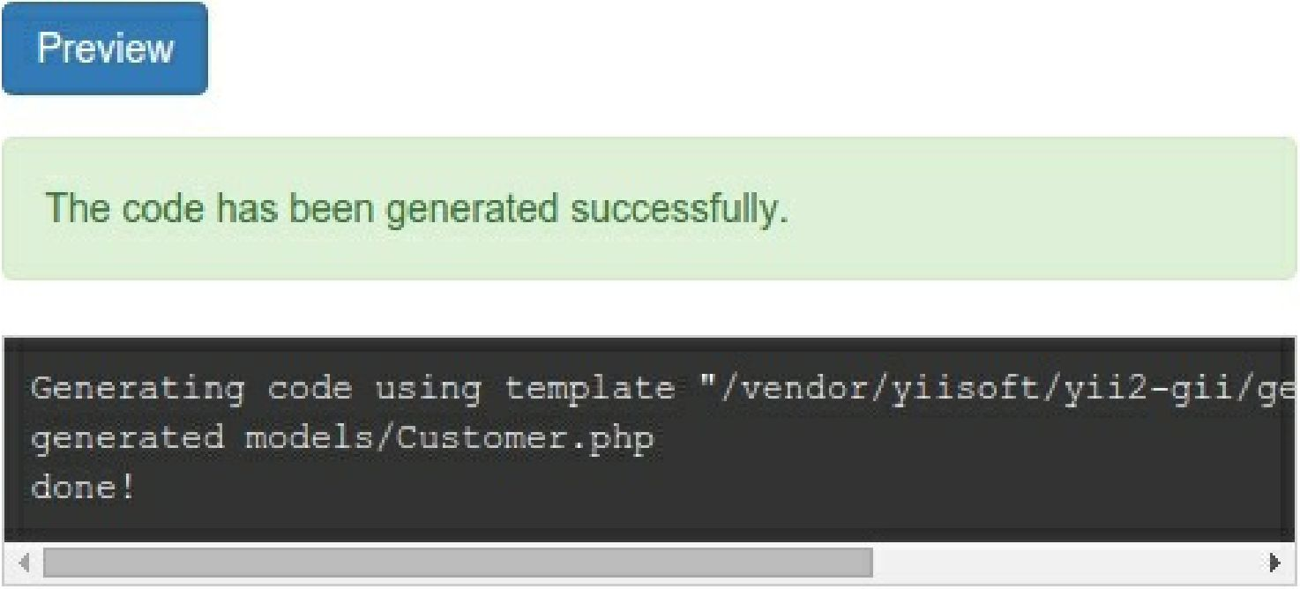

9. Check that the new class, \app\models\customer, exists.

10. CRUD is an abbreviation for the four common tasks using data on most websites: Create, Read, Update, and Delete. To create CRUD using Gii, select the CRUD Generator section. Specify your model class and type the other fields: